Jessica Conway

Advanced Macro Final Paper

Dr. Croushore

5/4/19

Forecasting in the International Sector

This past semester, I worked with the United States international sector in order to better understand its history, present situation, and potential future. By analyzing the historical trends of five variables in the international sector and utilizing three main forecasting methods, I developed two year forecasts on net exports as a share of GDP, foreign direct investment as a share of GDP, the exchange rate with China, a broad trade weighted dollar index, and income receipts on US assets abroad as a share of GDP. In this paper I will give a general overview of the sector as well as the importance of each variable within it. I will then explain how I went about finding the best forecasting model for each variable and finally compare these forecasts with the predictions made by professional forecasters and what these potentially mean for the future of this sector. The forecasting methods I used for this paper were ARIMA modeling, VAR, and exponential smoothing. In order to determine which models within these frameworks were the best fit for my data, I compared the Bayesien Information Criterion (BIC), which decreases as a model becomes more suitable for a given dataset. While there is no way to determine the BIC for VAR modeling, I will qualitatively compare the forecasts between these models.

In general, international trade and relations are a fundamental component of the United States economy. With the United States being the second largest exporter of goods, and the largest importer, maintaining balance in the trade world is essential. In recent years, however, we have experienced an increasing deficit in the current account balance, mainly driven by the trade deficit with China, as the United States has become an increasingly import based economy. Factors such as tariffs, interest rates, economic growth, and dollar strength can all play key factors in the future of this industry. This past year has been a dramatic year for the international sector, with increased global trade conflict and currency risk. This past year, increases in the interest rate to 2.5% caused a global emerging market currency crisis and a consequential strengthening of the US dollar. Further, global trade tensions prompted by President Trump’s increase on various import tariffs have raised uncertainty regarding the future of trade relationships with some of the US’s largest trade partners, specifically China. While these tariffs were aimed at decreasing the widening trade deficit with China, retaliation tariffs and increased demand further drove the deficit to reach record breaking levels in the fall. Looking forward, it will only be increasingly important to understand where various factors of the international sector are moving so that policy makers and economists can be better equipped in decision making. One of the most essential variables for understanding this sector is net exports.

Since 1980, the United States has run a trade deficit, which grew substantially from 1995 to 2005 (see appendix 1 on **page 4**). The majority of this deficit comes from the trade relationship with China, making up 66% of the imbalance in imports and exports. In the past few years, net exports as a share of GDP has remained relatively constant around -3%. Historically, the US has been a net exporter since the 1980’s, and this imbalance has shown an increasingly negative trend since. Key factors in driving net exports are the strength of the US dollar, tariffs, consumption and GDP growth.

Next, the trade weighted US dollar index measures the relative strength of the US dollar compared to large global trade partners. When the dollar is relatively strong, we expect imports to become cheaper and exports to become more expensive, driving down net exports overall. Factors that can affect the strength of the dollar are economic growth and the interest rate. This past year we saw severe inflation in developing countries partially in response to changes in the US interest rate, making the dollar relatively stronger in 2018. Historically, this variable appears to exhibit cyclical trends around a relatively constant value.

Another factor relating to the current account deficit is income receipts on US assets abroad. When these are doing well, it is a positive factor for the current account balance. They experienced a strong upward growth trend prior to the 2008 recession, in which income receipts dropped significantly. They have experienced more steady upward growth since this period.

Another central variable to the international sector is foreign direct investment (FDI). The United States received upwards of $4 trillion dollars in 2017, which came mostly from the UK, Japan, and Canada. FDI is important as it increases production in the US through infrastructure and other investment. However, FDI, which has maintained relatively stable upward growth historically, has appeared to slow after a sharp incline around 2014. This poses issues for employment and growth in the US. Further, because trade tension is a factor affecting FDI, concerns regarding whether recent political tensions will negatively affect FDI have arisen. As a share of GDP, we see a highly volatile trend in yearly FDI as a share of GDP.

Finally, it is important to understand the exchange rate between China and the US. Because China is our largest trade partner, as well as the largest source of the trade deficit, understanding the relative exchange rate between the US and China is helpful in understanding how imports and exports will change in the future. In the last 5 years, the Chinese Yuan has decreased in strength relative to the US dollar. Throughout 2017, the Yuan began to strengthen, reaching a peak in early 2018. However, in the last year, the dollar became relatively stronger again, perhaps in relation to the global currency crisis.

**Appendix 1 - Graphs and Descriptive Statistics:**

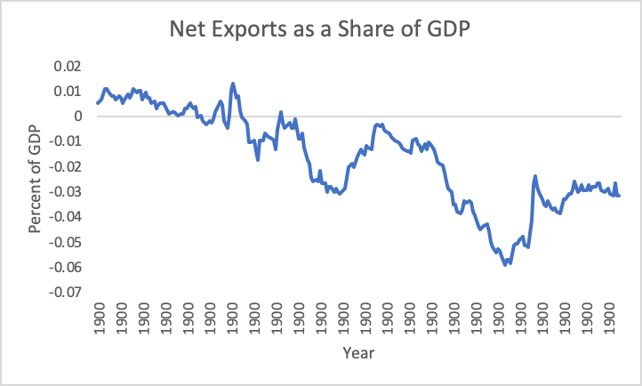

Min: -0.059

Max: 0.013

Mean: -0.017

Median: -0.013

SD: 0.018

Current: -0.032

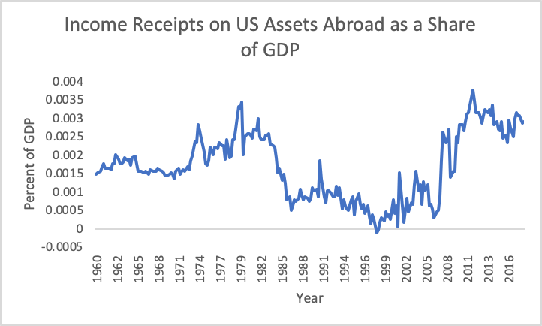

Min: -0.000104

Max: 0.00377

Mean: 0.00167

Median: 0.00160

SD: 0.000897

Current: 0.0029

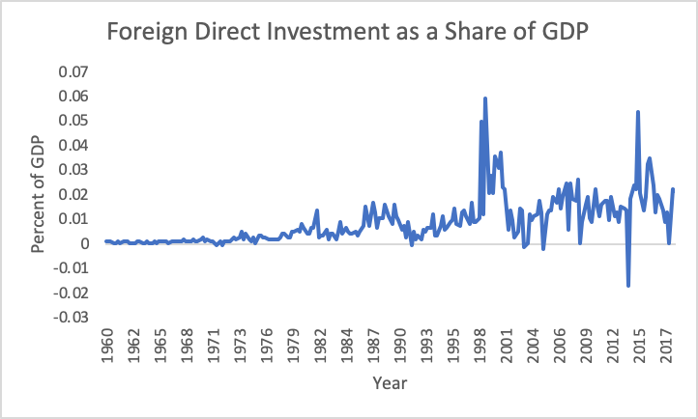

Min: -0.017

Max: 0.059

Mean: 0.014

Median: 0.013

SD: 0.011

Current: 0.022

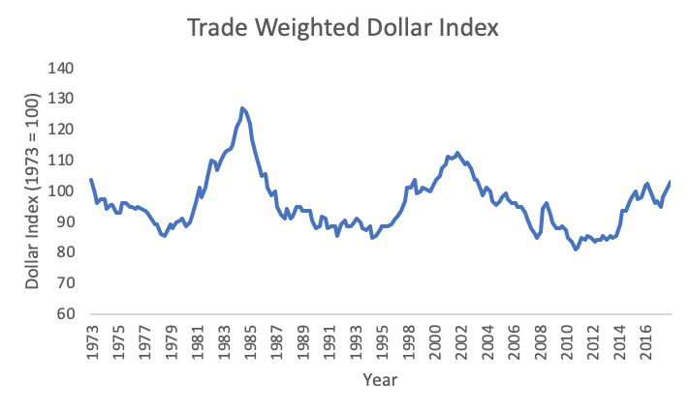

Min: 81.2

Max: 127.1

Mean: 95.9

Median: 94.7

SD: 9.08

Current: 102.7

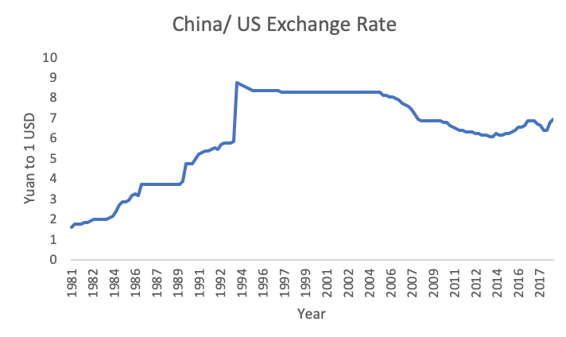

Min: 1.59

Max: 8.72

Mean: 6.17

Median: 6.60

SD: 2.14

Current: 6.91

An important part of forecasting is understanding the decision environment, the forecast object, statement and horizon, and the methods and complexity of each variable. The key component of the decision environment is the loss function, which details the potential danger related to forecasting error for a specific variable. For example, if underestimating a variable could cause more potential damage than overestimating a variable, this could be reflected by an asymmetric loss function. A common standard loss function in forecasting is L(e) = e^2, representing exponentially increasing loss as the forecast strays away from the actual on both the positive and negative side. Because I do not believe there are significant potential losses stemming from over or under-estimation in any of my variables, I believe a standard exponential function will suffice for each. Further, based on the constraints of the models we are using, as well as the adaptability of interval forecasts, I have decided to use interval forecasts for each variable, which give a specific forecast as well as confidence intervals around each. Finally, it is important to find a balance between including explanatory variables and keeping forecasting methods simple, as often simpler models are more effective. As this forecasting project is limited to the curriculum of the course, the models I ran were both univariate (ARIMA and smoothing) and multivariate (VAR).

For net exports as a share of GDP, the forecast statement I intended to answer was: How will the share of net exports in GDP change in 2019 and 2020? The information set I decided on was the quarterly, seasonally adjusted annual rate of net exports of goods and services from 1960Q1 to 2018Q4 as a share of GDP. This data was downloaded from FRED’s website.

For income receipts, the question I aimed to answer through forecasting was: How will return on US assets abroad change in the coming 2 years? The information set consists of quarterly primary income receipts minus quarterly primary income payments from 1960Q1 to 2018Q4 as a share of GDP. The choice to divide by nominal GDP was to combat the effect of inflation on the nominal variable, which is the case for all variables depicted as a component of GDP. The primary income data was downloaded from the Bureau of Economic Analysis, while nominal GDP data was downloaded from FRED.

Next, with foreign direct investment, I aimed to answer: How will foreign direct investment change throughout 2019 and 2020? The information set I originally decided on was quarterly, seasonally adjusted foreign direct investment (asset flow) from 1960Q1 to 2018Q4, downloaded from FRED, as a share of GDP. However, after a failure to achieve white noise in the ARIMA modeling process, and looking at the characteristics of the original data plot, I determined that a large change in volatility occurred around 1990, which could potentially affect the success my forecasting. Therefore, I decided to shorten my time horizon and start at 1990Q1.

By forecasting the trade weighted dollar index variable, I sought to answer the question: How will the strength of the US dollar change over the next few years in relation to other global currencies? This question is key in understanding how trade dynamics will change in the near future. The data used was the real trade weighted broad US dollar index on goods with a base year of 1973. The data was quarterly and not seasonally adjusted and was available from FRED from 1973Q1 to 2018Q4.

Finally, using the exchange rate with China I aimed to determine how the relative strength of the Chinese Yuan to the US Dollar will change in 2019 and 2020. The data I used for this variable was the quarterly, non-seasonally adjusted exchange rate of the Yuan to one USD from 1981Q1 to 2018Q4, downloaded from FRED.

The first method of forecasting I conducted was ARIMA modeling with and without unit roots. In order to do this, I first had to determine the best fitting trend and seasonal model combination in terms of BIC for each variable. Then, by examining the autocorrelations and partial autocorrelations of the residuals of these models, I determined the best combination of moving average (MA) and autoregressive (AR) models measured by the lowest BIC value. For example, if there were a few significant AC’s and oscillating PAC’s, this would signify an MA process. By comparing similar models until the lowest BIC was found, I was able to determine the best ARIMA combination. These models were then analyzed for white noise using the Ljung-Box test. If the resulting p-value of this test is less than 0.05, the data is not a random, white noise sequence within reasonable confidence. If it is greater than 0.05, we fail to reject the null hypothesis of white noise, passing the white noise test. As ARIMA modeling relies on reducing the data to random error, passing the white noise test is essential. If white noise was achieved, forecasts were created from the best models. I then ran KPSS and ADF unit root tests to determine the potential presence of unit roots in the data. As these tests are not deterministic, the original process was repeated by implementing a unit root (I = 1) regardless of outcome, and the final BIC’s of each best model were compared. What I found was that all variables were better modeled with a unit root except for FDI which favored no unit root.

For the dollar index, I first determined the best ARIMA model with no inflicted unit root. By BIC, I determined that a linear trend model with seasonal differences was the best fit. Then, by analyzing the AC’s and PAC’s and checking BIC values, I found that an ARIMA(0,0,4) model was the most successful non-unit root model. However, this model did not pass the white noise test, signaling an error. After running the ADF and KPSS unit root tests, the ADF test signaled a potential presence of a unit root. After repeating the process above with an inflicted unit root, I determined that a mean trend ARIMA(0,1,1) model had the lowest BIC of all (815.12), which passed the white noise test. Therefore, I determined this to be the best ARIMA model for this variable.

Next, I conducted a similar process for the exchange rate with China. I began by determining the best seasonal and trend model for a non-inflicted unit root, finding that a linear trend with seasonal differences had the lowest BIC. Based on the significant AC’s and non-oscillating PAC’s as well as an analysis on various options through BIC, it was determined the best ARIMA fit was an ARIMA(1,0,0) model. However, after analyzing white noise through the Ljung-Box test, we rejected the null hypothesis of white noise. After double checking that I indeed had found the best fitting model, I continued the process while inflicting a unit root. The KPSS test indicated the presence of 2 unit roots, while the ADF test indicated the potential presence of 1. Similarly to the dollar index, perhaps the presence of one or more unit roots was the reason my initial ARIMA model had failed to achieve white noise. After inflicting a unit root, it was determined that just a mean trend model was the best by BIC and that an ARIMA(1,1,0) was the overall lowest BIC of all of the models (-37.81). Finally, this model passed the white noise test and forecasts were created.

The next variable I modeled was income receipts. A similar process determined that an ARIMA(1,0,0), mean and seasonal difference model had the lowest BIC for non-unit root models, while the ARIMA(1,1,0) mean model had the lowest BIC for inflicted unit root models. The second model not only had a lower BIC overall, but passed the white noise test, making an ARIMA(1,1,0) mean trend model the best ARIMA model with a BIC of -3129.98. This makes sense as both the KPSS and ADF tests predicted the presence of 1 unit root.

Next, I conducted ARIMA modeling on FDI. After initially modeling FDI as a share of GDP with both a unit root and without, I found that neither of the best models passed the white noise test. By looking at a plot of the data, I determined that there were large discrepancies in fluctuations before and after 1990, which was a potential reason the ARIMA models were failing to achieve white noise. I decided to re-run the modeling process using the data from 1990 to 2018 to account for this problem. Through a similar process as the previous variables, it was determined that an ARIMA(1,0,1) linear model had the lowest BIC compared to the ARIMA(0, 1, 1) mean model, with both now passing the white noise test. So, overall the ARIMA(1,0,1) model was superior with a BIC of -729.78.

Finally, I looked at net exports as a share of GDP. I determined that the best non-unit root model was an ARIMA(0,0,4) linear model with seasonal differences (BIC of -2024.18), which passed the white noise test. However, I found that both the KPSS and ADF unit root tests detected a unit root. I then determined that the best unit root inflicted model was a ARIMA(0,1,1) with just a mean model (BIC of -2084.17), which also passed the white noise test. Clearly, the unit root inflicted model had a lower BIC. Therefore, our best model was a mean ARIMA(0,1,1) model.

**Appendix 2 - ARIMA forecasts:**

Trade Weighted Dollar Index:

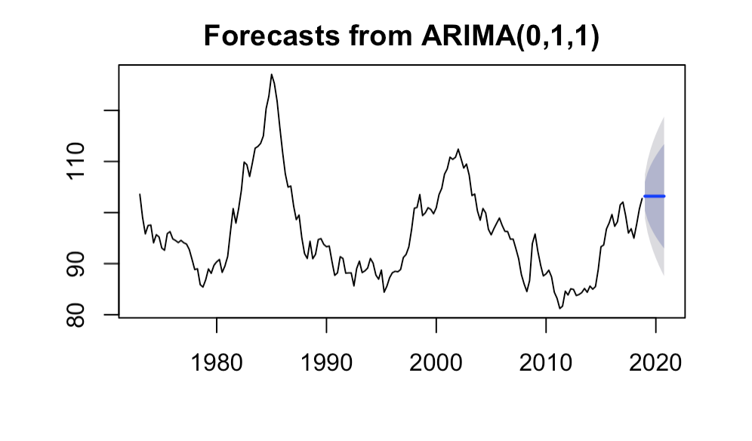

Exchange Rate with China:

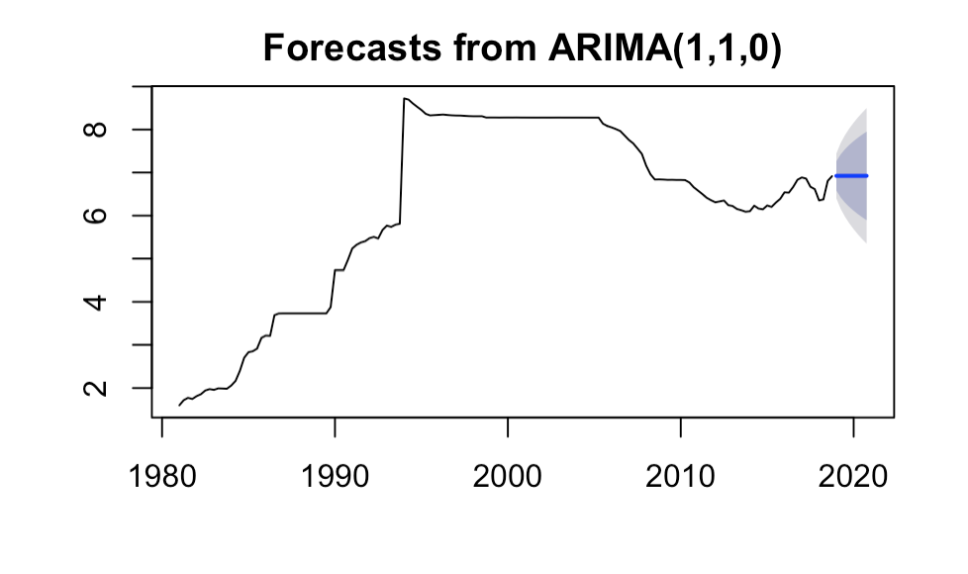

Net Exports as a share of GDP:

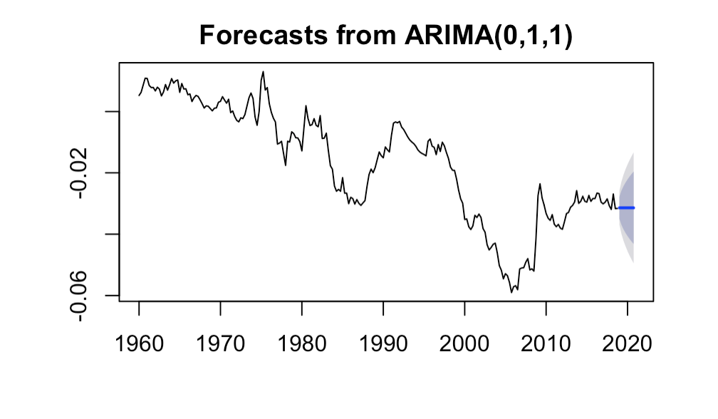

Income Receipts as a share of GDP:

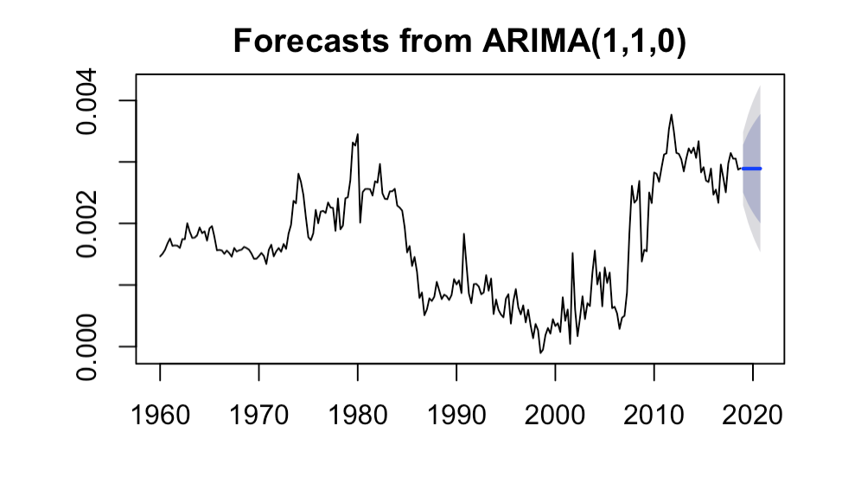

FDI as a share of GDP:

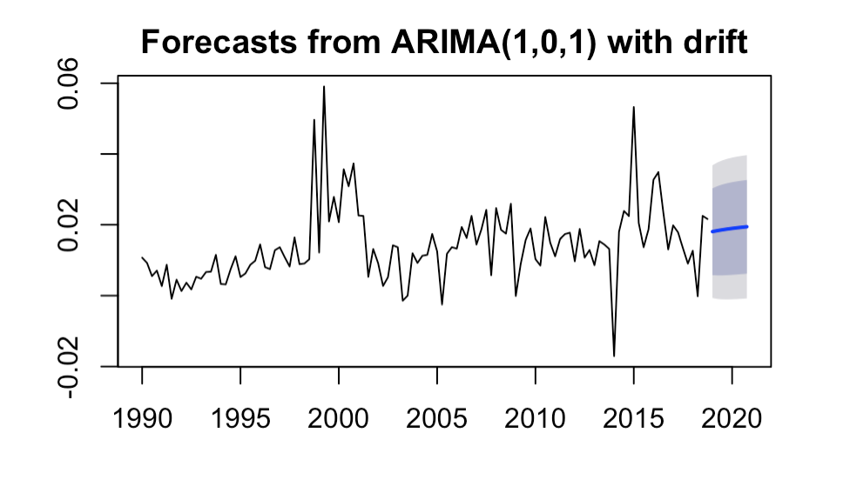

The next method of forecasting we conducted was a multivariate method called Vector Autoregression (VAR). By comparing the granger causalities and impulse responses of various correlated variables, I was able to determine contemporaneous and lag effects of GDP and interest rates on my five variables, as well as the effects of combinations of the five variables on each other. I determined a set of seven VAR’s that I thought would result in the best forecasts based on the relationships within the variables. For VAR’s, the order in which variables are placed matters. It is important for the first variable to be the least contemporaneously affected by the other variables, with this pattern continuing throughout the order. Impulse response graphs are included in appendix 4 on **page 21**. I will discuss the VAR’s that showed the most significant and logical relationships and therefore most reliable forecasting information.

The first VAR consisted of real GDP, net exports as a share of GDP, and the exchange rate with China. I determined that GDP should be the first variable in the regression as it is likely less volatile in the first period than either net exports or the exchange rate. I then determined that the exchange rate should be the last variable as I predicted it to be more volatile contemporaneously. This VAR determined that GDP was granger affected by itself in lag 1 and net exports in lag 1. Net exports were determined to be affected by GDP in lag 1 and lag 3 and itself in lag 1, and, finally, the exchange rate was only affected by itself in lag 1. I was a bit surprised by these results. Specifically, I was surprised that the exchange rate was so unaffected by either variable. Based on the impulse responses, we see that GDP, net exports, and the exchange rate had significant lasting effects on themselves. Further, net exports had a significant, negative effect on real GDP in time 2, which is inconsistent with theory.

The next VAR conducted was on real GDP and FDI as a share of GDP. FDI was placed second as I believed it to be more likely to be contemporaneously affected than GDP. It was similarly determined that neither variable had a significant effect on the other, but each had a significant effect on themselves in 1 and 2 lag periods. Beyond initial effects of each variable on themselves, it appears that FDI investment had a significant, negative impulse response on GDP in time 3. This finding is also inconsistent with the idea that FDI should increase production.

The next VAR I conducted included income receipts as a share of GDP and the dollar index. The order I decided on was income receipts followed by the dollar index, due to the likelihood that currency fluctuations are more contemporaneously volatile than income receipts on US assets abroad. This VAR then determined that the dollar index is affected by itself in lag 1 and 2, and income receipts are affected by themselves in lag 1 and 2 as well as the dollar index in lag 1. The impulse responses showed a slight significant, negative response from income receipts on the dollar index in time 0.

The final VAR I ran included the 3 month T-Bill, real GDP, and the broad dollar index. I ran this regression because I wanted to determine how interest rates would affect the dollar index, a highly relevant relationship in today’s global world. I placed interest rates first as it is less likely to be changed contemporaneously by either other variable, and I placed the dollar index last because I believe it to be the most affected variable, specifically by the interest rate. It was determined that the interest rate was significantly affected by itself in all lag periods, GDP in lag 2 and the dollar index in lag 1, signifying a quick response to currency changes. GDP was shown to be responsive to itself and the interest rate in the first two lags. Finally, the dollar index was significantly affected by itself in lag 1, 2 and 4 as well as the interest rate in lag 3 and 4.

The impulse responses for this VAR show that the interest rate had a significant, positive effect on GDP growth in times 0 to 2, but no significant impulse response in the dollar index. GDP showed a slightly negative response in the dollar index in time 0 followed by a positive significant response in time 8. Finally, the dollar index showed no significant responses in either the interest rate or real GDP.

The best VAR forecast for each variable was determined by how accurately the VAR responses followed economic theory as well as the size of the confidence intervals. For example, I chose to use the VAR forecast involving the interest rate for the dollar index over the forecast using income receipts because interest rates were demonstrated to have a significant effect on the strength of the dollar as predicted. Lastly, the forecast on this variable had smaller error. (See appendix 3 on **page 15**)

**Appendix 3 - VAR Forecasts:**

*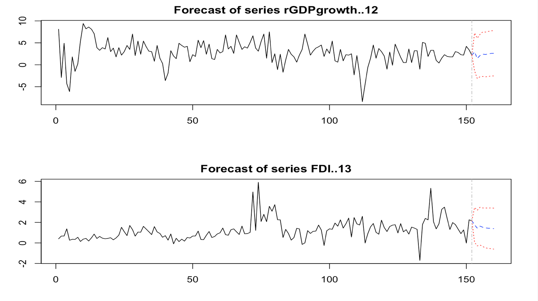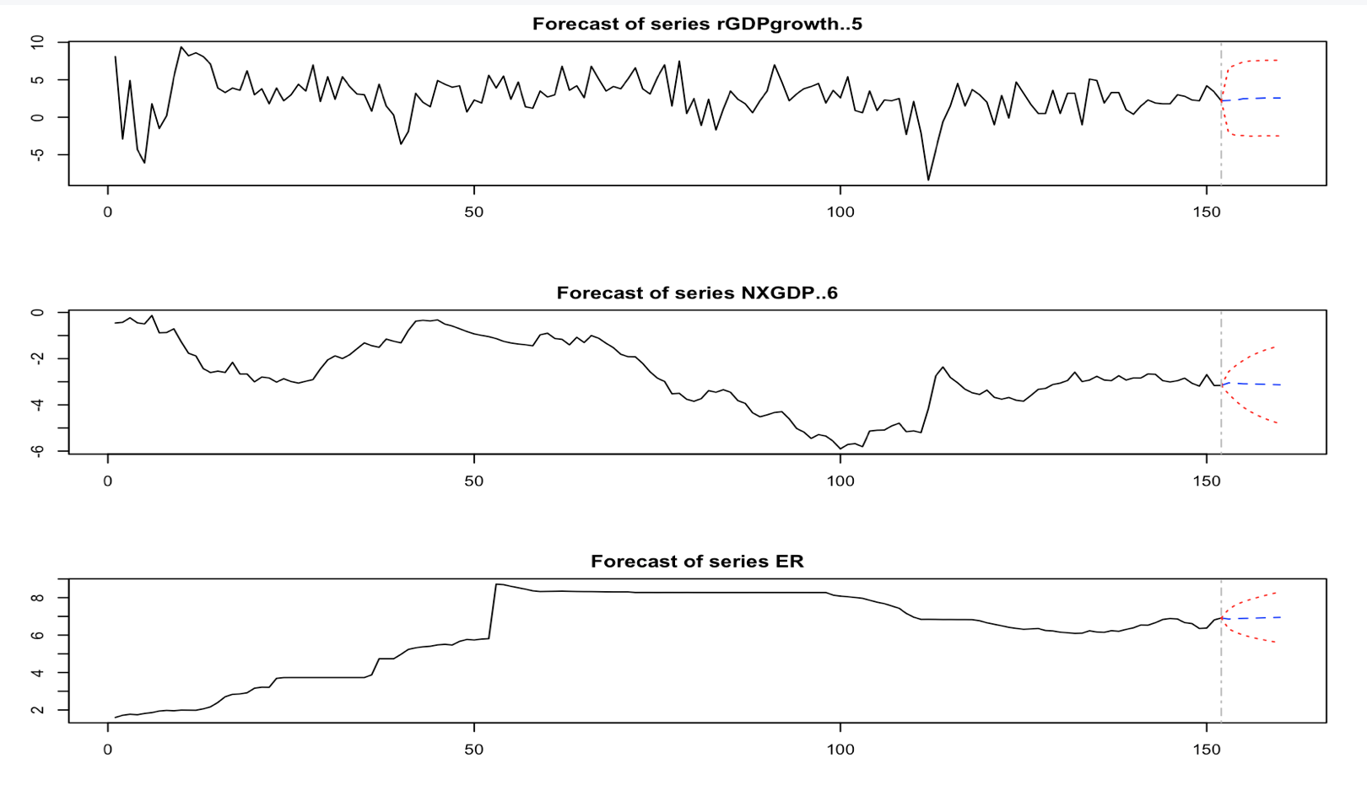****VAR #1:*** *real GDP, NX/GDP, China/US ExRate* ***VAR #2:*** *real GDP, FDI/GDP*

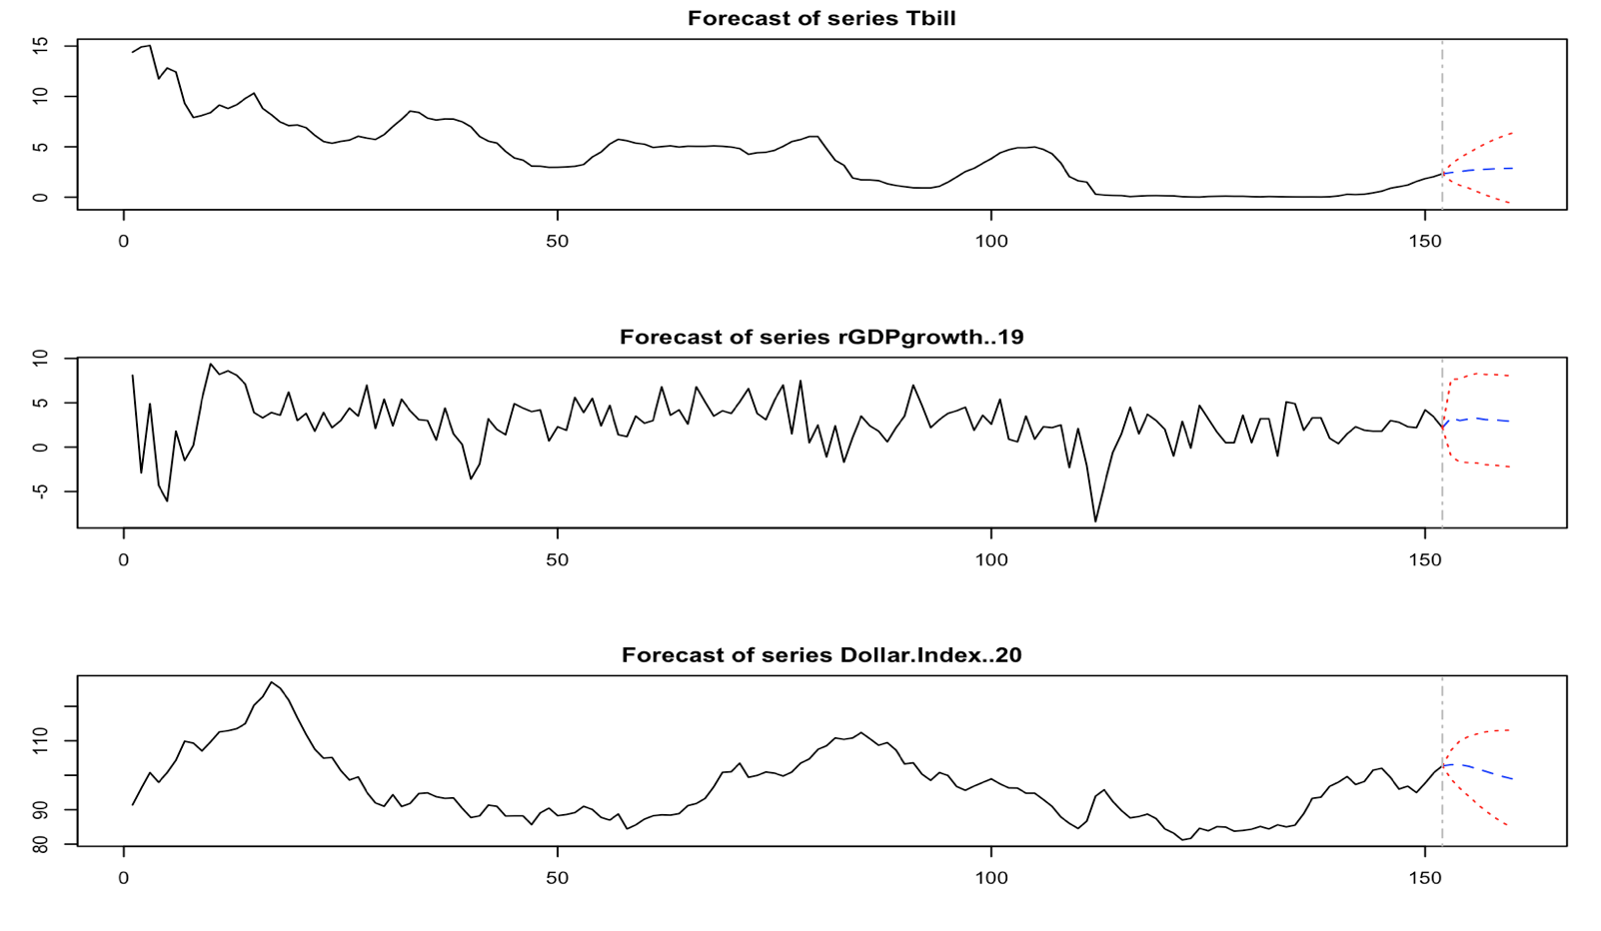

***VAR #4:*** *Interest Rate, real GDP, Dollar Index*

*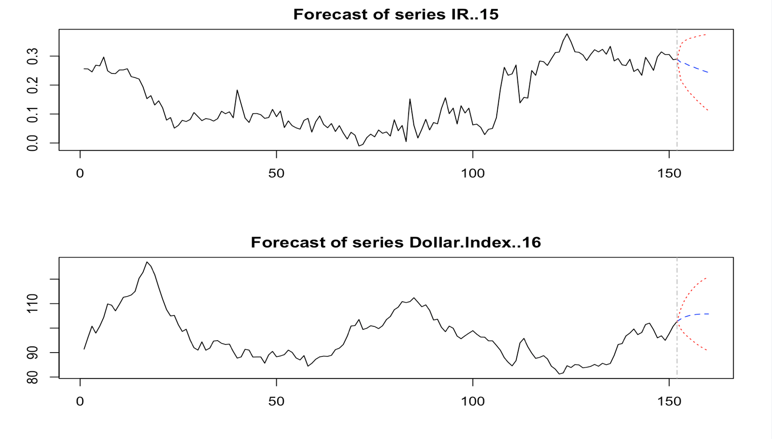****VAR #3:*** *IR/GDP, Dollar Index*

Finally, the last method of forecasting we used was smoothing. We sampled three separate smoothing methods and compared alpha and BIC values for each to find the best suiting model for each variable. Overall, I found that each variable had the lowest BIC for simple smoothing when compared with either the Holt or Holt-Winters method which both had large error bounds. Alpha values for this method, however, were mainly close to 1, except for FDI as a share of GDP which had an alpha equal to 0.2866. (Alpha values for simple smoothing = DI: 0.9999, NX: 0.9999, ER: 0.9999, IR: 0.7171, FDI: 0.2866). So, while the simple smoothing methods had the lowest relative BIC values for the smoothing models, the BIC values found for the ARIMA models were much lower overall for each variable and the alpha values were close to 1, making the smoothing models less reliable.

**Appendix 3 - Simple Smoothing Forecasts:**

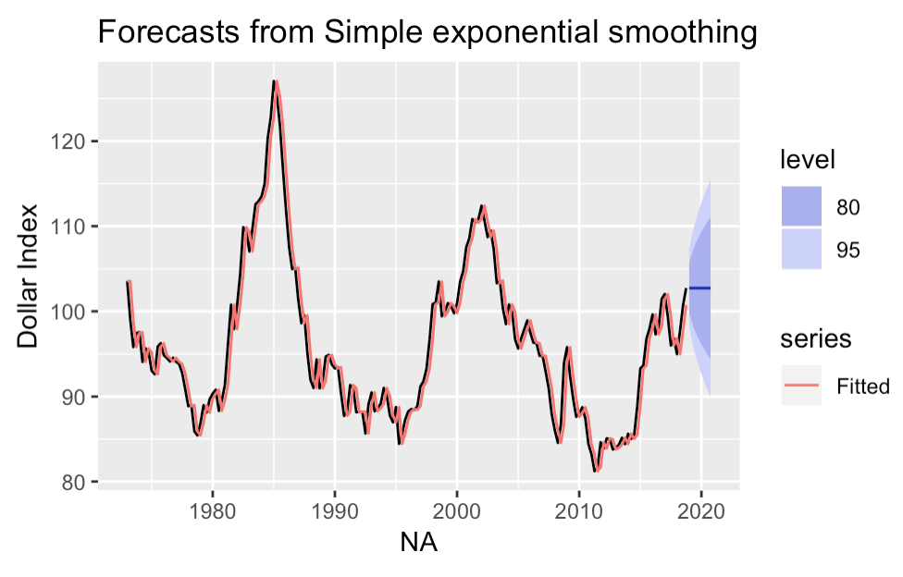

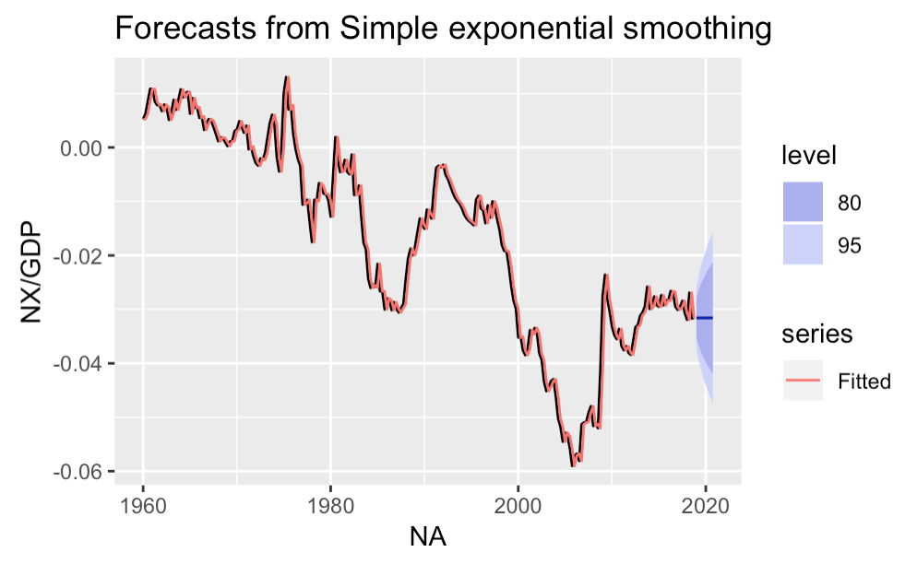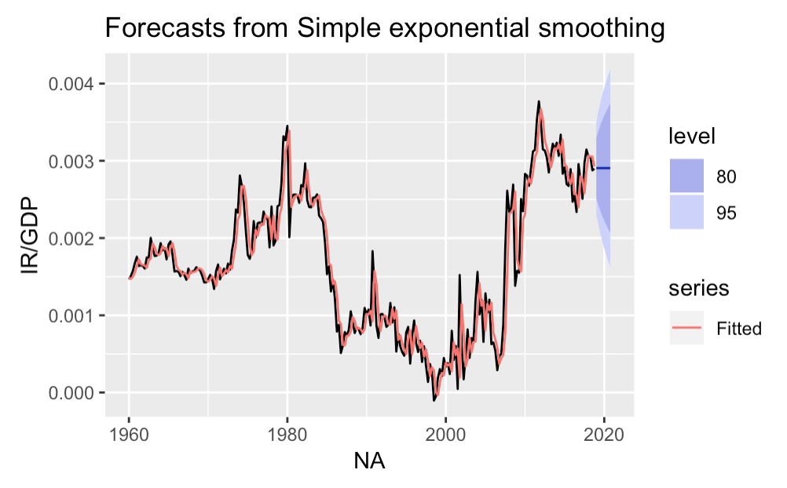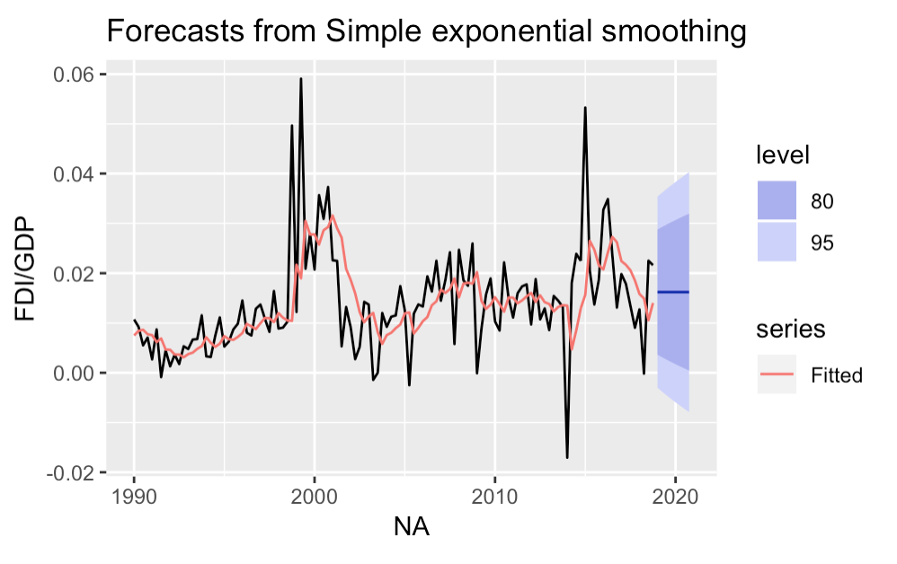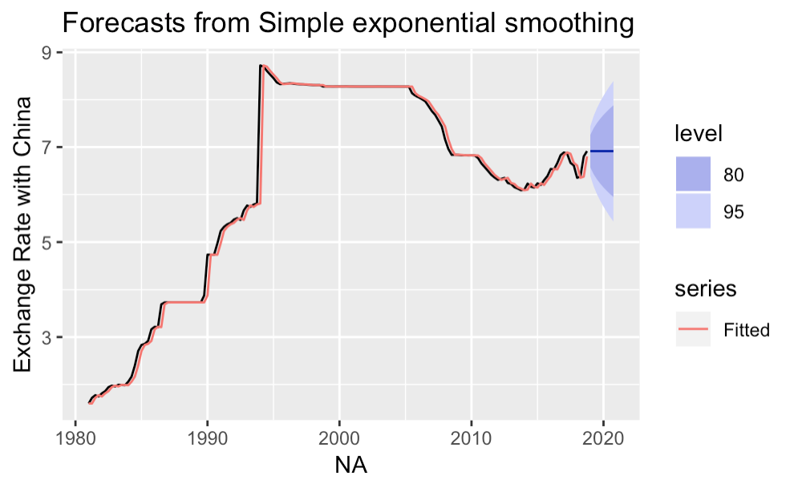

Overall, the ARIMA forecasts had significantly lower BIC’s than the smoothing models. The smoothing models in general had high BIC and alpha values and less logical forecasts, which drives me to put nearly no weight on them. All methods appeared to have similarly large confidence intervals, so it was difficult to compare them based on this factor. The VAR’s allowed for a multivariate approach, and gave strong insight into how the variables affect each other through granger causality and impulse responses. However, some results were not consistent with economic theory, creating some potential error in these forecasts. Overall, I believe considering both the univariate ARIMA model forecasts and the multivariate VAR forecasts would allow for the best understanding of the international sector in the next few years. However, due to the simplicity of the ARIMA models in terms of their univariate approach, I would weight them higher than the VAR forecasts. As we saw in class, averaging various forecasting methods can often lead to the most accurate numbers. Therefore, it could be beneficial to consider the average of both the ARIMA and VAR forecasts. However, because we only have two sufficient methods and outcomes, both with large confidence intervals, this would likely not lead to an increase in accuracy. (See table 1 on **page 18** for best forecasts)

**Table 1: Best 2019/2020 forecasts for each method with upper (UB) and lower (LB) bounds.**

*Note: lower bounds are highlighted in red and upper bounds are highlighted in green for clarity*

|  |  |  |  |  |  |  |  |
| --- | --- | --- | --- | --- | --- | --- | --- |
| **Variable** | **Model** | **2019Q4** | **202Q4** | **2019 LB** | **2019 UB** | **2020 LB** | **2020 UB** |
| **Dollar Index** | ARIMA | 103.1832 | 103.1832 | 92.4663 | 113.9001 | 87.5784 | 118.7880 |
|  | Smoothing | 102.7455 | 102.7344 | 93.7228 | 111.7460 | 89.9902 | 115.4786 |
|  | VAR #4 | 101.8497 | 98.9755 | 91.6946 | 112.0048 | 84.8475 | 113.1036 |
| **Net Exports** | ARIMA | -0.0314 | -0.0314 | -0.0439 | -0.0232 | -0.0495 | -0.0196 |
|  | Smoothing | -0.0316 | -0.0316 | -0.0428 | -0.0204 | -0.0493 | -0.0139 |
|  | VAR #1 | -0.0309 | -0.0313 | -0.0430 | -0.0189 | -0.0482 | 0.0145 |
| **Income Receipts** | ARIMA | 0.0029 | 0.0029 | 0.0019 | 0.0039 | 0.0015 | 0.0043 |
|  | Smoothing | 0.0029 | 0.0029 | 0.0020 | 0.0039 | 0.0016 | 0.0042 |
|  | VAR #3 | 0.0026 | 0.0024 | 0.0016 | 0.0036 | 0.0011 | 0.0038 |
| **China/US ExRate** | ARIMA | 6.9228 | 6.9228 | 5.8198 | 8.0258 | 5.3479 | 8.4978 |
|  | Smoothing | 6.9143 | 6.9143 | 5.8683 | 7.9603 | 5.4351 | 8.3936 |
|  | VAR #1 | 6.9004 | 6.9471 | 5.8944 | 7.9064 | 1.3573 | 8.3044 |
| **FDI** | ARIMA | 0.0162 | 0.0162 | -0.0053 | 0.0378 | -0.0081 | 0.0405 |
|  | Smoothing | 0.0162 | 0.0162 | -0.0052 | 0.0376 | -0.0079 | 0.0403 |
|  | VAR #2 | 0.0153 | 0.0139 | -0.0035 | 0.0341 | -0.0603 | 0.0339 |

Now, after comparing my own methods with each other and determining my best forecasts given the curriculum constraints, I wanted to see how my forecasts match up with professional forecasters’. While I was only able to find professional forecasts for 3 of my variables, this comparison will still allow for some understanding of how well my findings fit professional views.

Wells Fargo predicts that the dollar index will be 88.8 in 2019 and 85.3 in 2020, while ING forecasts it to be 89 in 2019 and 85 in 2020. My best forecast, the ARIMA model, determined that the trade weighted dollar index would instead stay constant at 103.18 in 2019 and 2020, differing quite significantly from those of the professional forecasters. However, my VAR predicted that the dollar index would be 101.85 in 2019 and decrease to 98.98 in 2020, which is more similar to those of ING and Wells Fargo, but still higher.

The Berenberg Bank forecasts that the China/US exchange rate will be 7.00 at the end of 2019 and 2020, and the DNB predicts it will be 6.8 and 6.9 respectively. My ARIMA forecast, instead, found that the exchange rate would stay constant at 6.90 into 2019 and 2020. The VAR forecasting found a similar trend of 6.90 in 2019 and 6.95 in 2020. While these differ slightly from the professional forecasts, it is much closer to the predictions than my forecasts on the dollar index and appear to generally follow the forecast consensus.

While I was not able to find a direct comparison for net exports as a share of GDP, the OECD predicts that net exports will move from -754.51 in 2019 to -863.65 in 2020, and Wells Fargo predicts, instead, that net exports will be around -1017.6 at the end of 2019 and -1016.8 in 2020. Further, the OECD predicts that the current account balance will drop from -2.9% of GDP in 2019 to -3.3% in 2020, and Trading Economics forecasts a movement from -2.2% to -2.5%. Although I did not forecast the current account balance or the level of net exports, net exports as a share of GDP make up a large portion of the current account balance. My ARIMA modeling predicts that net exports will remain constant at -0.0314% at the end of 2019 and 2020 while my VAR model predicts a slight decrease from -0.0309% to -0.0313%. While these forecasts cannot be directly compared with the values of the professional forecasts, it appears that my forecasts show a similar downward trajectory of net exports, especially through the VAR model. My ARIMA model, however, predicts a constant trend in net exports, which differs from the findings of the OECD and Wells Fargo.

Clearly, the comparison between my forecasts and professional forecasts varies between model and variable. While my forecast on the dollar index was quite far from what professional forecasters believe, my forecast on the exchange rate with China and the general trend of net exports were more on par. Perhaps modeling the trade weighted dollar index requires better inclusion of key explanatory variables.

Overall, I determined that the best models for my variables were ARIMA modeling and VAR modeling. While VAR gave me useful insights into the dynamics of the variables and how they interrelate, the forecasts from the ARIMA model followed the parsimony principle best and had the lowest BIC’s. When compared with other forecasters, I found that my results were similar for some variables, but quite different for others.

What would it mean for the international sector if my forecasts were to be accurate? One of the largest effects would be the sustained strength of the dollar. Because exports tend to increase when currency is weak, a strong dollar would imply an import dominant economy. Because I am forecasting net exports to remain negative, this could potentially be detrimental to the international sector past 2020 as it could lead to an even greater widening of the current account balance if the trend continues. Further, I am forecasting no growth in income receipts or foreign direct investment as shares of GDP, which wouldn’t negatively affect the current account balance, but rather not act as a counter balance to potential widening. My predictions on the exchange rate with China, specifically, also do not favor a weak dollar. As China is our largest trade partner, this could have large effects on exports past 2020.

While these forecasts can give potential insight into the coming years, there is significant potential error in these predictions for a variety of reasons. In general, forecasting is a challenging task, but with the limitations of one single forecaster, rather than an averaged survey, there is a larger likelihood for inaccuracy. Further, because these skills were developed in one semester by an undergraduate economics student and because we were limited to specific models, there is inevitably more error in my fundamental ability to understand and forecast variables in my sector. Lastly, unforeseeable future events are possible, especially in the light of a historically more erratic president, and threaten the unbiasedness and accuracy of these forecasts moving forward. Overall, this project has allowed me to understand the many nuances of data analysis and forecasting as well as given me insight into the difficulties that people in this field face. It is clear that one must be incredibly knowledgeable not only about economics and variable relationships but also about the fundamentals of modeling data – and perhaps be a bit lucky – in order to successfully forecast key macroeconomic variables.

**Appendix 4 - Impulse Responses:**

***VAR #2:*** *GDP and FDI/GDP*

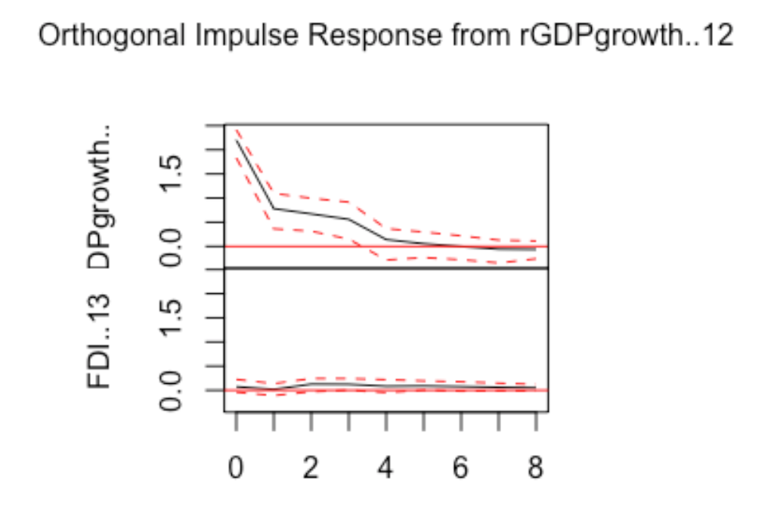

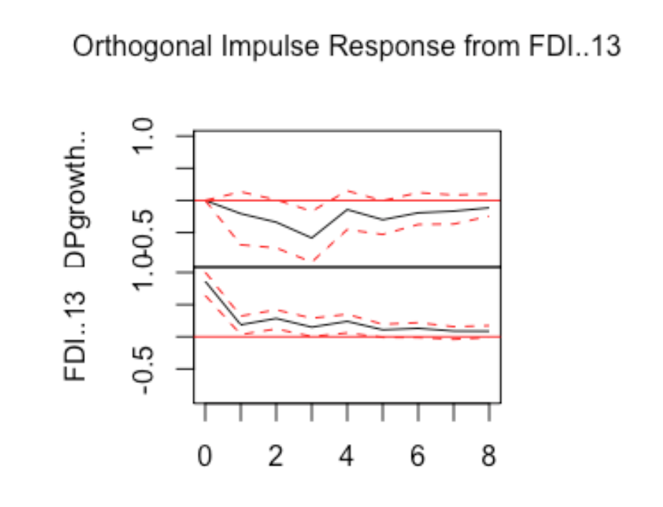

***VAR #1****: GDP, NX/GDP, China/US ExRate:*

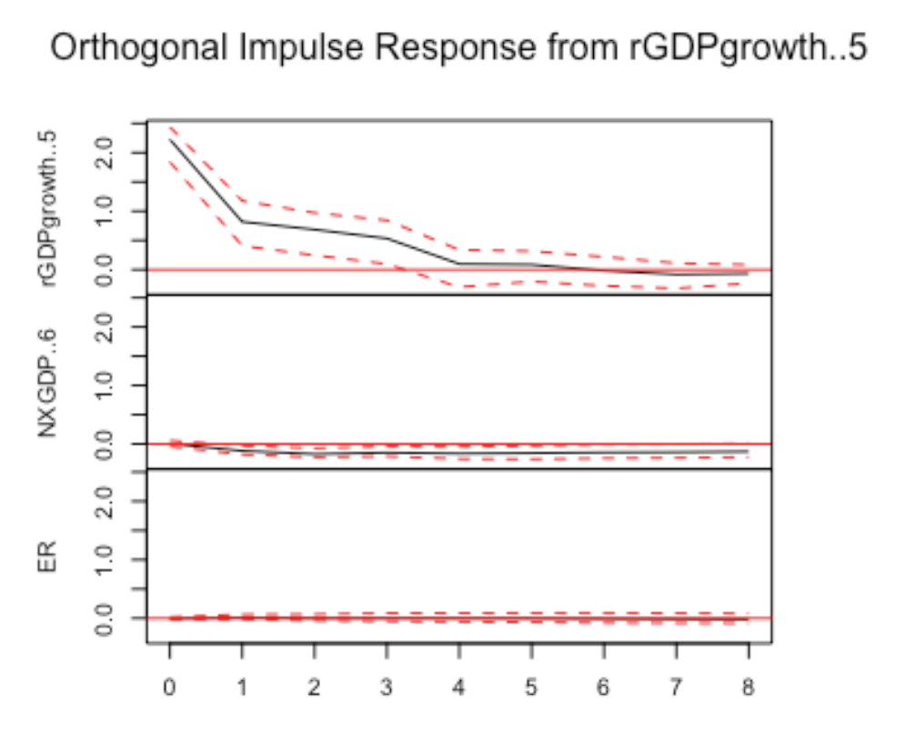

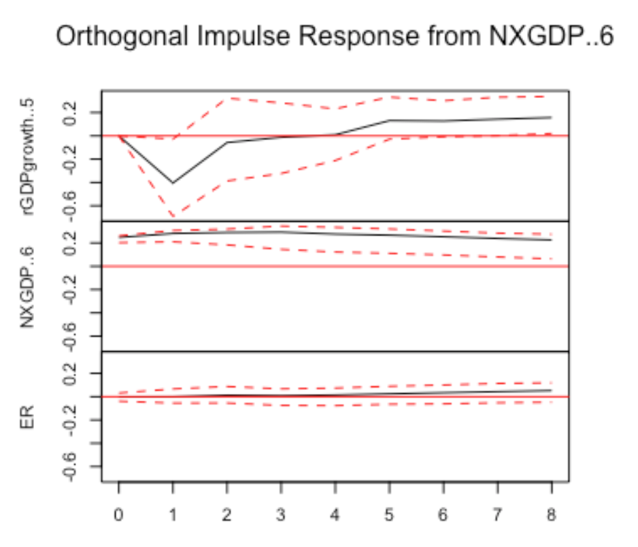

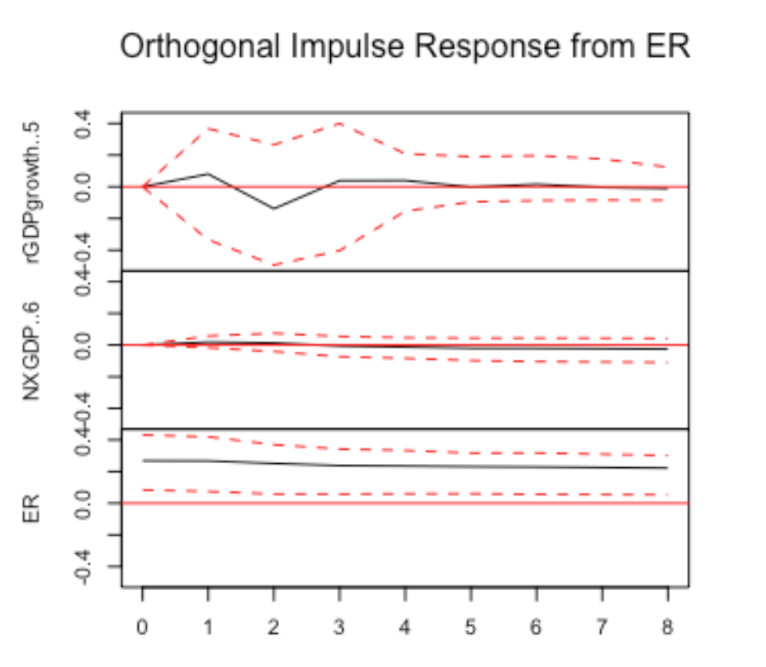

***VAR #4:*** *Interest Rate, GDP, Dollar Index:*

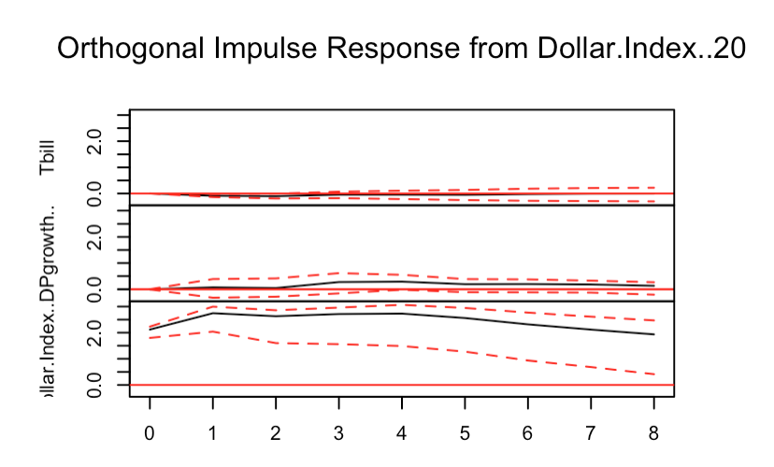

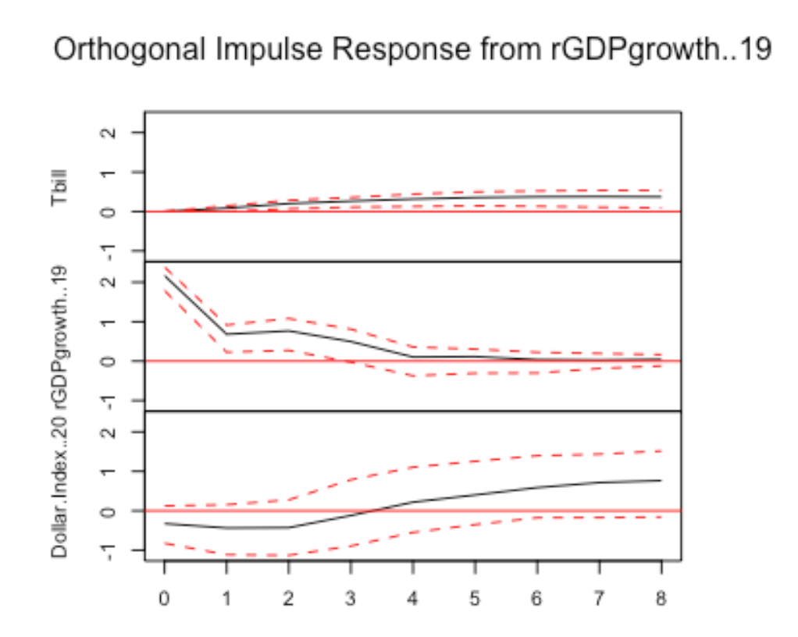

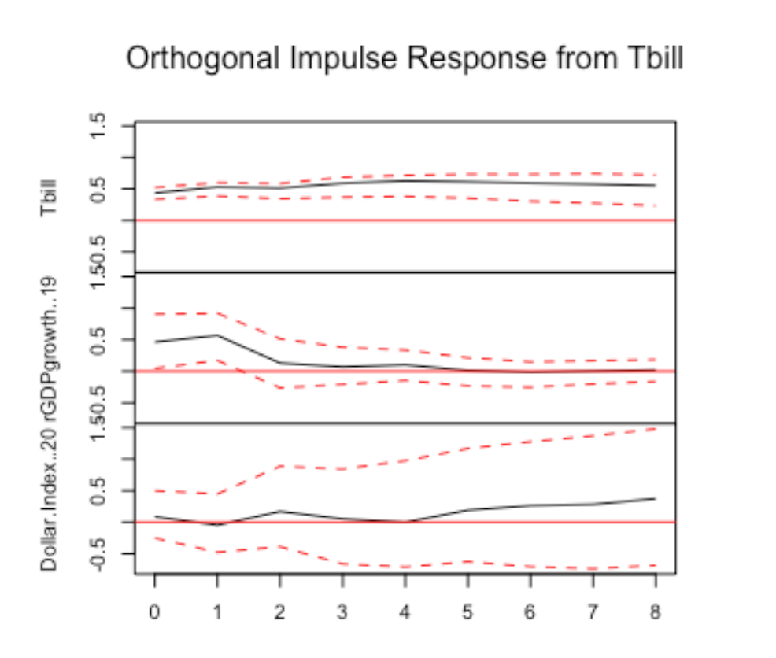

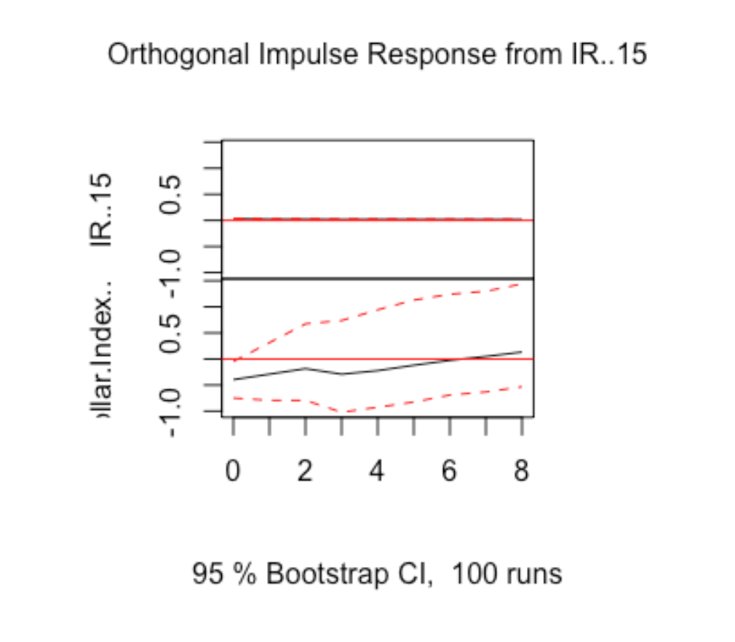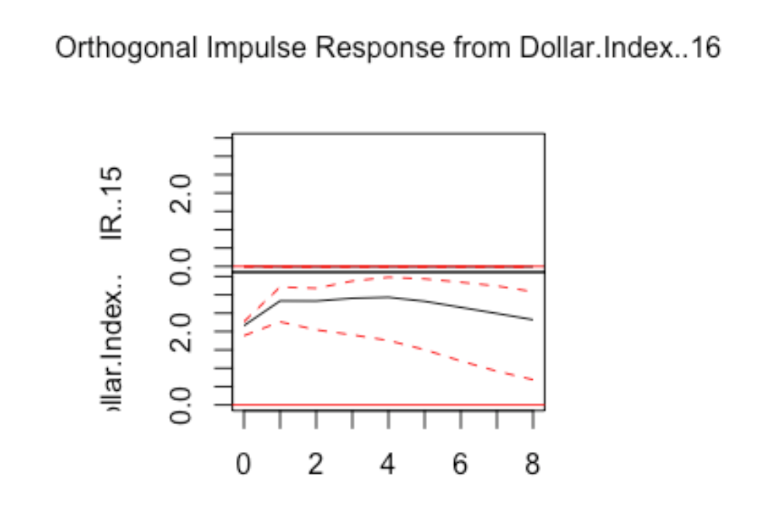***VAR #3:*** *Income Receipts and Dollar Index:*

Sources:

1. Bryan, Bob. “Trump Is Failing to Achieve One of the Biggest Goals of His Trade War, and He Only Has Himself to Blame.” *Business Insider*, Business Insider, 13 Dec. 2018, www.businessinsider.com/trump-trade-war-us-china-trade-deficit-growing-despite-tariffs-2018-12.
2. Economics, Trading. “United States Current Account.” *United States Current Account | 2019 | Data | Chart | Calendar | Forecast*, tradingeconomics.com/united-states/current-account.
3. Karunakar, Rahul. “Dollar's Unrivalled Surge This Year Will Reverse in 2019: Reuters Poll.” *Reuters*, Thomson Reuters, 6 Dec. 2018, www.reuters.com/article/us-forex-poll-euro/dollars-unrivalled-surge-this-year-will-reverse-in-2019-reuters-poll-idUSKBN1O5011.
4. Amadeo, Kimberly. “How the US Trade Deficit Hurts the Economy.” *The Balance*, www.thebalance.com/u-s-trade-deficit-causes-effects-trade-partners-3306276.
5. Buxbaum, Peter. “US Is Losing FDI.” *Global Trade Magazine*, The Authority For US Companies Doing Business Globally., 9 Aug. 2018, [www.globaltrademag.com/global-trade-daily/us-is-losing-fdi/](http://www.globaltrademag.com/global-trade-daily/us-is-losing-fdi/).
6. Housten, Elaine. “Exchange Rate Forecasts 2019 | 2020 | 2021 - April / May 2019.” *Exchange Rates UK*, 30 Apr. 2019, www.exchangerates.org.uk/news/25586/latest-foreign-exchange-rate-forecast-tables-april-2019-for-pound-sterling-euro--us-dollar.html.
7. “Federal Reserve Economic Data | FRED | St. Louis Fed.” *FRED*, Federal Reserve Bank of St. Louis, fred.stlouisfed.org/.
8. U.S. Bureau of Economic Analysis, “[Table 1. U.S. International Transactions](https://apps.bea.gov/iTable/iTableHtml.cfm?reqid=6&step=3&isuri=1&600=1),” (accessed March, 2019).
9. “OECD.” *OECD*, www.oecd.org/.
10. “Wells Fargo.” *Wells Fargo – Banking, Credit Cards, Loans, Mortgages & More*, www.wellsfargo.com/.
11. “Trading Economics Forecasts.” *Currencies - Exchange Rate - Forecast - 2018/2020*, tradingeconomics.com/forecast/currency.
12. ING.com. *ING.com*, www.ing.com/Home.htm.